Holiday Trash Pick-up Schedule
2025

Trash Pickup Monday & Thursday – starts 7:30am
Trimming Pickup Tuesday & Friday - starts 7:30am


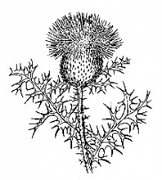
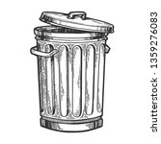

Holiday Trash Pick-Up Date | NO - Trimming Pickup
JAN 21ST Tuesday PU | APRIL 18TH
FEB 18TH Tuesday PU | JULY 4TH
MAY 27TH Tuesday PU |
SEPT 2ND Tuesday PU |
OCT 14th Tuesday PU |
NOV 26th Wednesday PU
* No pickup on Thursday 11/27 or Friday 11/28 *
DEC 26th Friday PU |
JAN 2nd 2026 Friday PU
** Some Trash days May change | ** Other Trim PU Days may be missed

